# Purpose of the solution

The purpose of this website is to address the problem of a lack of education or lack of confidence users of Micro:bits may have, by encouragement and an explanation of basic programming principles. This will include demonstrations, programming terms or information about topics. This website will need to be kid friendly as it will be a website for students and teachers, so it has to be upbeat and show micro:bit doing things to help them get enthused about it. The site will also have a section for teachers which will help them understand programming and also help teach their students enthusiastically. This website will focus on teachers and students of New Zealand.

# End user requirement

This website has two very different types of end users. On one hand you have kids that grew up with computers and the internet around them. The other hand you have got teachers that are new to in-depth concepts of computers. This means in terms of content the teachers should have access to something like a computer dictionary, so they can understand terms and differences between things like data types. Their content should also include tutorials the teachers themselves can do for their own education, and to help benefit their students. I must also design content for the students. I will offer the same “dictionary” as there is always a possibility of someone not knowing something. There will also be lesson structures and tutorials that will be set for them, and extra stuff if they complete it faster than normal. For the interface it needs to be suitable for kids to navigate, so a balance of aesthetics and usability will be needed as one may be partially sacrificed to fulfil the goal of keeping the kids engaged. The friendly interface will also be needed for the teachers as they may also struggle with navigation, however it should be ok as long as I stick with the conventions of website design as teachers would have developed internet habits by now.

# Plan

## Planning tools

### Gantt chart

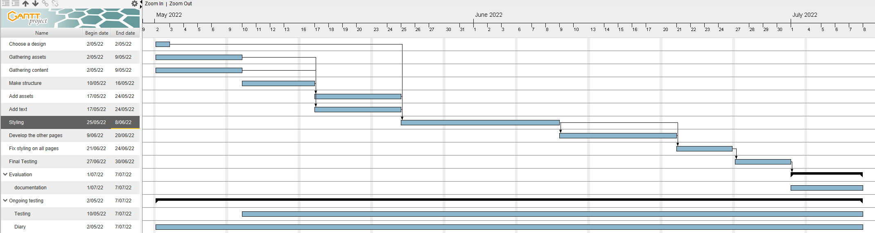

### Why did I use a Waterfall method over an agile method?

I used a waterfall method as It shows me a step by step process of everything I need to do before I can deem the website finished. Being able to see ever step decomposed into a timed list of things to is also easy to sustain as I am only one person, not a full team. This means I can readjust the plan to whatever I need without consequence. The waterfall methods I have gone with is a Gantt chart. The reason why I didn’t use an agile method such as Trello, flowcharts or Kanbans is because I personally like the waterfall method because I can see what must be done by specific dates giving me hard deadlines to ensure I complete them. It also lets me see what steps depends on previous steps being completed and it gives me an order to do them ensuring everything I need will be there on any given step. The agile method seems to require more time to use at its fullest. The agile methods work best in team situations that you get in industry where you need flexibility to take advantage of new possibilities, and you are working often with much bigger projects. The agile methods let the team leader move the project as needed in a way that I do not need to. I do not need a very flexible plan or planning system as I am working alone and don’t have to worry about others, so the stricter structure of the Gantt chart guides me well.

### Why did I use Gantt chart?

I used Gantt chart over other waterfall panning software because I have used in since year 9, so about five years. This means I am very comfortable with the software making laying out plans very simple and easy for me as I know where you find everything in Gantt charts. I also find Gantt charts very easy to read as it not cluttered and I am used to the software. Because of this I felt Gantt charts were my best options for brainstorming and laying out a plan for the development of my website.

## Problem decomposition

### Why did I use this order of steps?

I used this order as I felt it was the most optimal order to complete the steps as this order should have no back tracking and every step should have the appropriate resources to finish it.

1. Gathering Assets and Content: The gathering of Assets is important as I need images as they were a part of the design and they are a key element for the content as it can draw viewers in and inspire them to do something with the website’s information. The same goes for gathering content. I need to have something to talk about and having extra research about the website’s topic is never bad. This will be done first as knowing all the fact will make writing the content easier rather then doing it in the middle of development. Another reason of it being first is because its requirements to do, so I can get it out of the way at the start.
   1. Acquire content.
      1. Find articles and other websites to research and understand micro:bits more in depth.
      2. Gather statistics and opinions to talk about.
      3. Experiment personally with micro:bits to get an understanding of them
   2. Acquire pictures.
      1. Find and pictures and add them to the asset table.
      2. Save original image in case edited versions need to be removed.
      3. Crop, resize, tinting and other types of image editing will be used for each image.
      4. Save in jpg and png. Jpg will be compressed to 7 for optimal quality, and png will only be used if transparency is needed.
2. Make the structure: Making the structure will be the first step in coding the website. I will do this first because its layout outline and boxes of where everything on the website will go, it will also make styling and adding content a lot easier. This is because if I added objects at the start as a part if the structure, they will just be empty containers for content and styling.
   1. Make index page.
      1. Create the main structure of the page using both HTML and CSS.
      2. Add placeholders for images and text, that reserve space for slideshows and content.
3. Add the Assets and Content: This step is where you will insert the images and write the content. You would do this after the structure because all I would have to do is replace the placeholders with the real images and content making this step much faster. This is also required for the rest of the steps to continue.
   1. Add the actual content.
      1. Add images and a fully functional slideshow.
      2. Add all text content in.
      3. Must be spell checked and tested.
4. Style the page: Stylization of the page is the next step and will most likely take the longest as many things can go wrong while getting things to be sized and coloured correctly. The reason why we do this after the content was added is because we can see what the final product will roughly look like with all the images and text in the correct places. This step happens now as all steps before it is needed for it to be started and it is the ground work for the next step.
   1. Stylize the page.
      1. Add personal colours.
      2. Edit text size and font style.
      3. Add colour functions e.g. Dark mode.
      4. Create template for other pages to follow.
5. Develop the other pages: The development of other pages is the next task and will require the use of the last stylesheet and is the reason why the first page must be fully finished before the rest are started. This step should not be long as the first page can be used as a template. All I would need to do is change some of the layout and content which will be short, however it will take time as I will need to make four other pages that fully work.
   1. Develop other pages.
      1. Change some of the layout to suit the page better.
      2. Add content e.g. images and text.
      3. And functional features (Slideshow and Dark mode).
      4. Make links between all the pages.
6. Fix styling on all the pages: This step should take a small amount of time as all you would be doing is readjustments to the stylesheets to make sure everything fits correctly and looks nice. This needs all previous steps to be completed to start.
   1. Skim through all the page looking for issues.
      1. Fix some incorrect sizing.
      2. Incorrect colours.
7. Do final testing: This step is very important and crucial to the success to the website as this step will be all about testing and double checking everything in the website. This is where you will use a test plan to test functions and features of the page to ensure that they work fully. You will also need to proof read everything as well.
   1. Make a test plan
      1. Test all JavaScript based features to see if the work.
      2. Spell check all text.
      3. Make sure every image is in the correct place.
      4. Fix or finish any leftover features.
8. Documentation: Once everything else Is done a document will be made and used to evaluate the website. It will include a summery on how it went, how well it works and what improvements can be made.

Ongoing - Diary and testing: This will be done throughout the entire process as ongoing testing is good to do to ensure sections work and small thing don’t slip through the cracks when I am developing the page. The Diary will be used to Document development as it goes. It will reveal what things were changed, it will show feedback and a weekly update on what the status of the website is. It will also show screenshots of code and the actual page to fully show what has happened each week.

Evaluation

This project has logged all ongoing trialling and testing information with feedback in the Diary Document. The Write Up document was made before the website was made so this is the Final Report.

# How I applied user experience principles to improve the quality of the outcome.

I have used my understanding the User Experience Principle to improve the quality of the Digital Outcome as I developed the website with user feedback from user trialling to make the website function and behave as smooth as possible for end-user who come after development. This was done in multiple ways. The first in the planning phase was Snowballing Ideas about the websites design that the end-user may be interested in. like Slideshows, Theme selection and Dark Mode. These ideas were eventually incorporated into the design as they sparked interest in many possible end-users. While Development was ongoing Usability testing was done consistently throughout the entire development as bad code can severely harm changes or ideas that may happen in the future. A/B Testing was done periodically as they would give an Idea on how to shape certain sections of the page in the design and production parts. The reason is that if the end-users don’t like the product while it’s in development, they would not want to use it, when you don’t listen and change problem in the page.

**Value Proposition**

My website shows the use of UX as the Value proposition is clearly used throughout the entire Websites design and content. This is because the Value proposition allow me to design the page to the end-users and products benefit. We can see evidence of this in the content on the index page. As the content will not ever mention the pains and will only promote pain relievers in a way that is tailored to the end-user following the value proposition. The page also entices users’ images and slideshow in a high-profile location that show cool projects but also the simplicity. The value proposition also is shown in the Micro:bits page as it allows for the wide range of ages and skill the Micro:bit is designed for. As this page has a blanket description of what micro:bits for younger or newer audience, where the statistics are for older or more experienced users, the other half of the micro:bits audience. The value proposition also shows that a key feature of the Micro:bit, which is it’s to be programmed by children. The Lessons page takes advantage of this as there are two different content sets for the level of education. The web page and web site is enhanced by having this value proposition outcome in place because it talks about hat UX has deduced they will most be interested in.

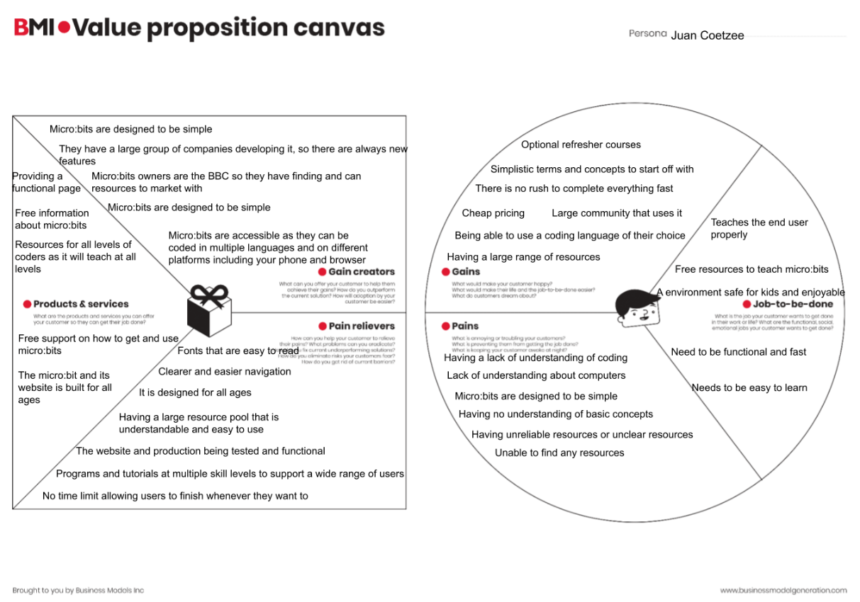

**Competitive audit**

The competitive audit has worked to the websites benefit in the website as it allows the Micro:bit website, and Gallery page by showing the strengths and avoiding weakness that the competitive audit has revealed. The way the Micro:bit and Gallery page does this, is by showing the end-users in a palatable as understandable what micro:bit is, what is in it, and what it looks like. While simultaneously not mentioning competitor. This creates a safe feeling about micro:bits by having an encouraging tone as the site is more about education then selling. However to get people into the idea of micro:bits the website never mentions competitors as doing so would provide a chance for people see them, which means less users for the website.

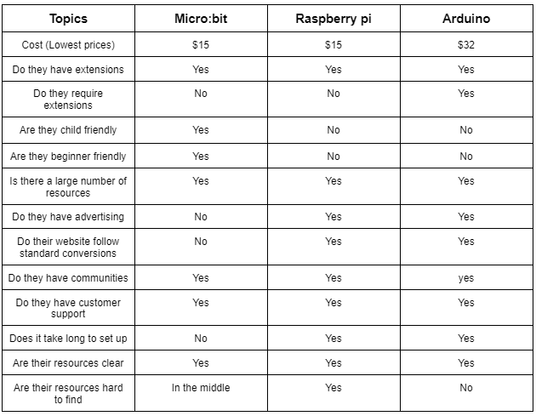

**Stakeholder Interview**

The Stakeholder interview was a key part of UX that allowed me to make the content of the Lessons, main, and pages. This is because these interviews allowed me to see what possible end-user think about micro:bits. This allows me to design the pages content to better complement the pros and cons of Micro:bits. For example a stakeholder that was interview was asked the question “What challenges can you face when using the Micro:bit?” He responded with “the support for kids is good the support for teachers is not that flash they assume that the teachers are on to it, and not all are.” This quote was the reason why the Lessons page has a more in-depth description on what is happening and how to achieve tasks. This was done so the teacher can still teach the class new ideas as they are offered more information, they would understand better. This allows for the teachers to gain confidence allow for a more effective classroom. Stakeholder interviews also allowed me to decide who the end-users were. This is because in the interview I ask “Do you think Micro:bit is better than its competitors. All three said no when you are talking about a professional level. However in a primary school level, Micro:bits offer an easy access to the world of technologies. Thus the target demographic was Teachers and Students at the primary school level.

**For the full Interview document please check the Stakeholder interview Document in the Admin folder.**

# Some of the feedback examples I used during ongoing trialling to improve the outcome

The best example of trailing in my website will be found at the diary entry of 23/06/2022. This is because this JavaScript was key to the one of the main features of the website, which was dark mode. It took many minor edits and some were screenshotted and others were commented in to the page for you to look at. However, the reason why this trailing session was so important is because it formed the bases of text swapping and theme changing. Without understanding how to achieve this. The website would have become impossible to build. Screenshots below compare the three.

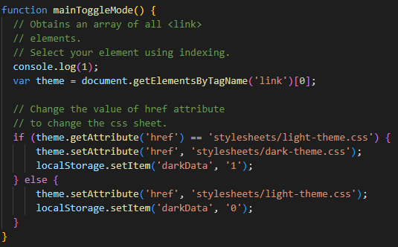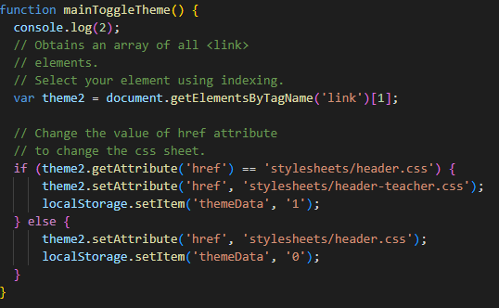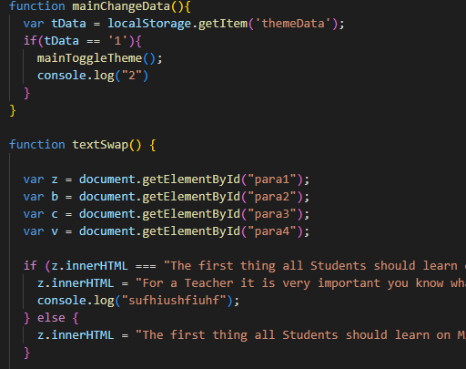

# What was the outcome of ver1 and what was needed to take it to Ver2 explain how the outcome of tests and trials informed the next version?

Version 1 was a design that had a bad colour scheme, good features and decent layout. The other two designs had the better layouts or colour scheme. However, gathering feedback from classmates’ teachers and reliever teachers (the whole group of end-users), it became clear by mixing the good attributes in to design one we would get an overall product. And gathering more feedback on version 2 showed me that this design was heading in the right direction as the colours were nice, features were good and the overall layout was much better and cleaner, so it would easier to understand for younger end-users.

# An explanation of efficient tools and techniques used in the production phase (e.g. editing techniques, versioning etc.)

Editing tools that were used were Visual Studio Code and Photoshop. These were the only two editing software used as they were all I needed. This is because Visual Studio Code can program HTML, CSS, and JavaScript. It was very easy to understand as it was clean and easy to read. Another reason why it was used over other editing software is the range of extension I can add onto it. These extension makes life a lot easier for me as it can range from automatic spell checking, a live HTML window. Another one that was very good was the GitHub integration as VSC will show me what has been pulled, committed or become a merged with the main branch. Photoshop was used as it is the world’s leading photo editing software and I have already had practice using photoshop for previous projects. This made editing photos a less of a hassle and overall, much quicker. Another reason why I used photoshop is because it was provided to me by the school, so I had no paywall, So I had free access to Photoshop, so I did not have to look for another software.

Versioning tool were GitHub and saving in the admin folder. The main software that was used for versioning is GitHub as it is fast easy to use and access. This is because GitHub is stored on servers and with the correct login I can store and retrieve any file that I have created throughout the whole project from any computer. This means moving data between from school and home was a lot less stressful. The other version tool I used was manual saving into the admin folder. This is because it provides a back-up like GitHub does, however as it is stored locally it is quick to access and very easy to keep making more. This is just a timesaver if I did make a mistake and had to restore some of the Website.

Editing techniques were the use of third-party code and adapting it into my website. It was common to adapt third-party code into the website, as sometimes things are two complicated to fully develop by yourself in a span of 10 weeks. It also gives me an understanding of what my code should look like and ways to manipulate it into doing what I want it to do. For example, the complete overhaul on how darkmode works was accomplished by the help of using W3schools as they shown me a template and how works and what it does allowing me to recreate different usages and forms like text change.

Run file validation in Dreamweaver to get a validation report for your code.

Hopefully it looks in good shape! Add the report to your collection when it

looks good.

I first went to W3.org and scanned the website there were no critical errors in the code. However, I forgot to add in the alt=”” inside most images so I had to fix all of them before I was able to get a green rating. When it came to non-code base validation Grammarly was often used to ensure my writing and my grammar were correct. Other than grammar errors and a few forgotten elements. There was no issue found in the page. 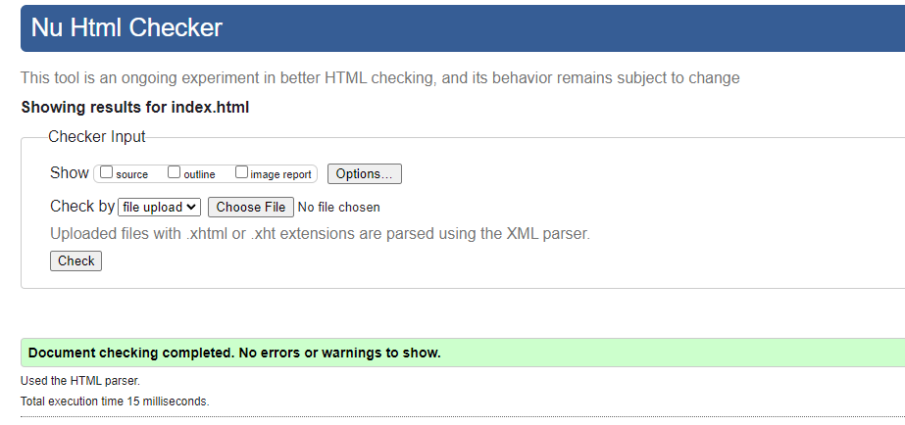

# Show your project organisation with respect to filing and naming of files

The file themselves were laid out before coding began as It good to know were to link and sink everything. It was also done to ensure it was as clean as possible for future development. The First screenshot is the main directory and all the code will be found in the index.html file, in the pages folder and the stylesheet folder. The reason for separating everything is to make pathing easier to do inside the code when I was link things together. Another benefit to sorting the pages files like this is it allows for copy and pasting pathways as many of these pages will need to use the same pathways.

The second screenshot is inside the images folder. The reason for so many subcategories is because it allows me to distinguish the image shape and purpose. For example, the I know all slideshow images are 1000px wide as that is how big they were made to be slideshows. These subcategories allowed for ease of understanding of the images that are going to be used.

folders (screen shots)

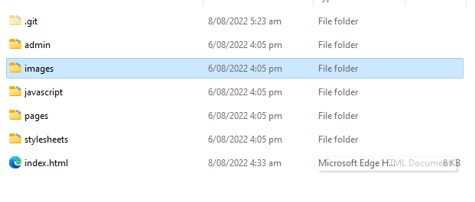

# Relevant implications that have been addressed in your outcome. How your outcome:

### Social

Social implication is about what something means to a society and computers are a vital part of this society as a whole and are increasingly more important. As computers become more important, more and more people should be capable of understanding computers, however current teachers and the education system are struggling to teach younger kids and teenagers. As many schools start to teach students, with teachers that don’t understand the topic causing confusion and slow progress on the subject. Creating a Social issue.

This will affect my website as many people want answers about programming in New Zealand and around the world and where to start learning. This is good for my website as the website will advertise a Micro:bit which is also offering a solution to their problem as the page will also teach them about it and how to solve future problems on their own.

My website will be working with the NZ public mainly in the school system, however it will be designed for anyone interested. The website will be helping teachers and students to understand how Micro:bits and programming work. It will be tailored to teachers and students as there is a lack of education in this area of schools as it is a new topic and many teachers do not have the correct education for it. The goal of my website is to fix that.

**How did my website address this?**

My website addresses the social relevant Implication by helping to get rid of the lack of education of computers in school around New Zealand. As a way to help this problem my website was designed for kids and Teachers alike as the Website provides information that is tailored to kids with easy wording and simpler instructions. Where the teacher gets a more information lesson on what the task is, and what the kids are trying to do. The idea behind this approach is to get the children interested idea of programming by using fun methods instead of confusing them with a large load of information. Teachers on the other hand need more information if they are going to teach the subject explaining their larger information load

### Culture

The website must be friendly towards cultures found in New Zealand. A good example is our Māori population as it has many connections to the natural ecosystem of New Zealand and because predators harm the connection that has been made, as the Culture is about giving back to the land. There are other cultures to respect too, but the main cultures of NZ are the ones I am working with.

However, this relevant implication does not affect my page that much or at all as this website is about learning how to program. So, all I can do is to make sure I can accommodate all groups of people that can be found in New Zealand.

**How did my website address this?**

My website addressed this by not categorising people by culture or anything else other then if they are a student or not. This still did not effect the website at all.

### Legal

This is an important one, as I need to make sure I credit people in my research to avoid breaking intellectual property laws. Avoiding a claim will involve me crediting people, asking for permission or buying them. This will make resource-gathering take longer as I need to find copyright free or gain permission to use them. The law is called the Copyright Act of 1994.

To do this I will be keeping an asset table to keep track of that need acknowledgements etc. I will probably credit everyone anyway for even balance and goodwill. This will be proofread to see that I have acknowledged everyone.

I will also need to follow the privacy act of 2020 but will mention more below.

**How did my website address this?**

My website addresses this relevant implication as I made sure that the copyright act of 1994 and the privacy act of 2022. This is because at the current moment in time this website does not take any data from the user So currently in Cannot violate the privacy act of 2022 as there is no data.

My website addressed copyright by making an asset table of all of the image and the requirements to use them. This also lead me to make a dedicated page on crediting the images to who owns them and who the authors are, and which license was in use for the image.

### Privacy

To follow the privacy act of 2020. I will need to make it clear what data I am using from users, for example if I was asking for an email I need to be clear of what I am using it for and if it is legal as well. A good example of people not following privacy laws was Facebook in 2019 illegally selling account details. This may not affect my website, as I do not think personal information is needed. If data is needed, I will need to make it clear that their data is protected and by not being sold to third parties. Will also delete the information after I am done with it. The information on how personal data will be used will be proofread.

### Ethical

This tells us if something's morals are meant to harm other people, the area is called bad ethics. Good ethics is when something is created without harming something else. This means I will not attempt to guilt trip them into buying micro:bits or using my website. I will also not take personal information without permission of the user.

Therefore, I will not attempt anything negative towards the end-user. For example, I will not take data without permission. I will also make sure that all of the tutorials and lessons are safe for kids and teachers to replicate.

### Accessibility

This is where you make the webpage for as many groups as possible. For example, can someone with poor eyesight read anything on the page or can colour-blind people see the colours I am using. These colours are dark and light shades of blue. This will affect the website's design, as it will need to be understandable to as many groups as possible.

This will be done on my Website by making images and text larger so people with vision problems can read my text and see what the images are depicting. The main theme is blue as it is aesthetically pleasing but it is one of the few colours that most colour-blind people can actually see. I will also have a darkmode for viewing at night or just for a colour palette change for the end-user.

Use of alt property in IMG tags and use of tags such as EM and STRONG instead of I and B as these are stressed and spoken in a text to speech reader for sight-impaired people.

**How did my website address this?**

My website addressed this by having a dark mode feature. This feature changes all the white to a very dark grey for the purpose of being less harsh on the user’s eyes and allows for a better viewing experience at night, another small thing for your eyes is that the white is dimmed do it will not hurt people’s eyes. The colour palette was also influenced as we chose colours that people with colour-blindness can see for a better experience. For easier read much of the text also increase in size. This because younger users will be using the page, this means it must be clear to read for the best results om kids’ reading.

### Usability

This is how much I can put into the website. Features that effect usability are hyperlinks, videos and images. This feature can cause problems in a website as images may not appear or text hyperlinks failing can make a bad experience that is slow and annoying. The features can also ruin styling if done incorrectly. Although they give more content, you must test for bugs.

My website will make sure all the content it holds will be tested and in the right position on different browsers. I will also not be doing anything super complicated, as I do not feel they are needed, as the most difficult thing will be the slideshow. This will be mainly fixed by testing buttons and links to see if they do as intend by using a test plan.

**How did my website address this?**

To make sure the website was usable There was a lot of trialling and testing to make sure all functions work, although I said I wouldn’t do something complicated, I did and have made it consistently and successfully work. Images was resizing check on all browsers to ensure there was not issues in sizing. And text was proof-read and check multiple times over. Things were checked with end-users to see find annoying and bothersome bugs

### Functionality

This is about how well the website achieves its processes; this does mean this implication co-exists with usability and aesthetics. This is because working aesthetics draw people in with visual features. Then usability is for the content with the website, like images and text to let the website do what it was designed for. This is because if it fails people will leave.

This is also a matter of testing and user feedback, as these features will allow me to manipulate the design to appeal more to my end-user. The feedback may look like, bigger text, more images or bigger images. This will be easily tested because I will have a test plan that will make it easier to find things that may not work properly.

**How did my website address this?**

The website currently functions as intended all JavaScript features are up and running and fully tested to find any possible errors that may occur. If any bug was found by ongoing testing the bug would be fix or removed as soon as possible. The current functions work really well with Aesthetics as toggle theme and dark mode are key functions in this website. And due to testing the usability also was better as there was more to do, but all of it would be tested a lot to ensure they don’t break.

### Aesthetics

This is about the visual aspect of the website. This is where websites draw people in to actually look at the content as a messy website may cause people to lose interest. Good aesthetics may come from the layout, the sizing and colour because if these fail it may cause a forgettable or ugly website no one will go on. Feedback is an important factor for the aesthetics, as User-feedback from the end-users will allow me to make the website look more appealing to the topic and them.

I have made all my colours go towards accessibility, which should allow for as many end-users to have a good experience on the page. I also have made sure that the layout is super easy to understand as it follows a wide amount of conventions and I have also made sure to use my UX research to good use as I also designed the layout of the web page to use my value proposition as best as possible. I will have to test if the layout is working properly and if the colours are the correct ones, the content and images must be the correct size for the layout to work using a test plan to find these issues. I have experimented in my designs with the use of gaps, borders and tones of colours to get the best aesthetical balance for the site. People are very influenced by the style of what they see.

**How did my website address this?**

Theme that was chosen to make the Usability better as the colours are not intrusive and are bright enough for the information you need This websites theme was designed to help people with colour-blindness as blues can be seen most of them. Aesthetic was important but usability took a bigger priority.

### Personal Health Developing this page

For personal health I became healthier as I started to counter how much I sit down with exercise However every 30 minutes or so I would stand and stretch to prevent my back from hurting.

For the health of the end-user I ensured that all Lessons were kid safe and cannot break valuable toys or the end user may hurt themselves on accident while trying to experimenting as thing may fall or fingers getting jammed.

**Is this website sustainable and future proof?**

The website was built to teach people how to program micro: bits and it gets them started on the road. This website can provide a sustainable line of work as More and more Lessons can keep getting added. Not just that there is also an opportunity to add a database to the website to allow newsletters and to store data. The website is future proof as Micro: bits are becoming a more relevant introduction to programming and this page provides a good place to start. The website was developed with future users in mind as it follows conventions growing in popularity. Ensuring that the page will have a relevant design for a few years.